1. Graphical user interface, application

   Description automatically generated  
   
2. Chart

   Description automatically generated with medium confidence  
   There is one thing to understand about kafka msg.
3. Each Kafka Msg within in a single partition is uniquely identified by 64 bit integer offset.
4. For example the offset for the 1st msg will be zero and for the next one will be one.
5. This numbering continues across the segments (partition 0 = a set of segments) within the partition to keep the offset unique within the partition.
6. Let’s assume that the offset for the last msg is 30652 and assume that the maximum limit is reached.  
   So, the kafka will close this segment and creates a new segment file for the next msg and continue the offset sequence.  
   The offset for the 1st msg in the new segment continues from the last msg in the previous segment.  
   Hence, the offset for the 1st msg in the new segment will be 30653 as the offset for the last msg in the previous was 30652.
7. For easily identification, the segment file name will be suffixed with the offset of the 1st msg in the segment.
8. 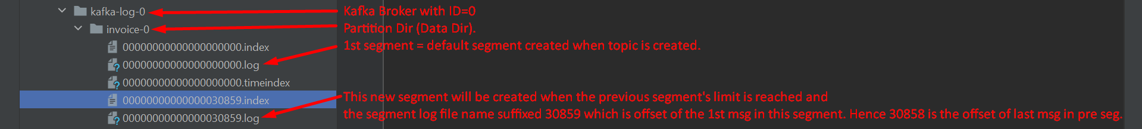
9. **NOTE**: Offset is unique for a partition across all the segments (all segments reside inside the partition dir)  
   But offset is not unique across the partitions.
10. Since offset is not unique across the partitions, so if you want to locate a msg, you need three things. Text

    Description automatically generated with medium confidence